**CONSULTATIVE WORKSHOP ON PLANT HEALTH COMPAIGN ORGANIZED BY PCAS & MSSRF**

***“The healths of soil, plant, animal and human are indivisible”***

* M.S.Swaminathan Research Foundation and our college jointly organized a workshop on Plant Health Compaign on 17.12.2019.
* Dr. Rajkumar,Chairman, M.S.Swaminathan Research Foundation and Mr.S.Arunachalam, Deputy Director, Horticulture explained about illness of plants and its remedies.
* From this workshop, students acquired more knowledge about different plant diseases and its control measures.

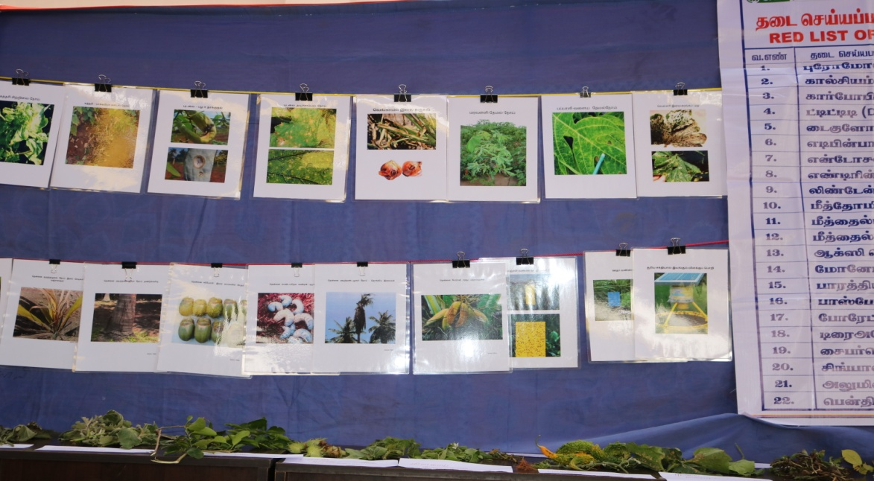

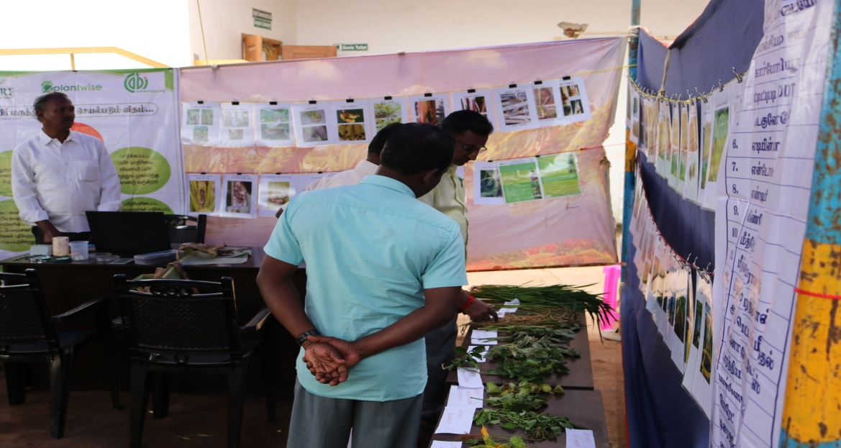

**PLANT HEALTH CLINIC CUM CONSULTATION ORGANIZED BY PCAS & MSSRF**

* M.S.Swaminathan Research Foundation and our college jointly organized a workshop on Plant Health Clinic on 22.03.2021
* Dr. Rajkumar,Chairman, M.S.Swaminathan Research Foundation and Mr.K.Joel Prabhakar, District Youth Officer, NYK, Pudukkottai.
* From this workshop, students and farmers acquired more knowledge about different plant diseases and its control measures.

